# Department of Physical Medicine & Rehabilitation – Grand Rounds

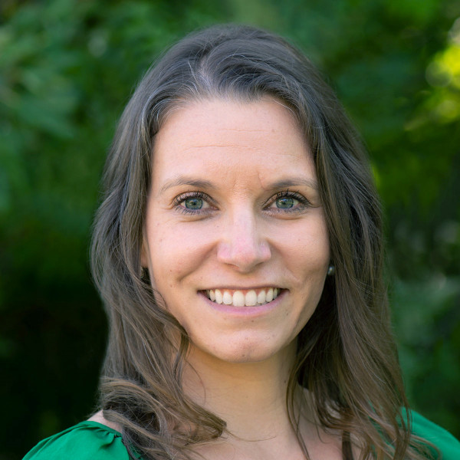

**Title:**  **Stroke rehabilitation: Finding the balance in intensity**

**Keynote Speaker:**  
Dr. Jamie Fleet, MD, FRCPC, CSCN Diplomate (EMG), MSc (Candidate)

Assistant Professor

Department of Physical Medicine and Rehabilitation

Schulich School of Medicine and Dentistry

Western University

Monday, October 21, 2024

Parkwood Main Auditorium, B2-109  
8:00 am - 9:00 am

Question & Answer Period: 8:45 - 9:00 am

**Learning Objectives / Presentation Summary:**

1. Describe definitions of rehabilitation intensity and outline its significance for recovery
2. Discuss recommendations from Canadian Stroke Best Practice Guidelines for stroke rehabilitation intensity
3. Explore current evidence around stroke rehabilitation intensity and associated outcomes

*This event is an Accredited Group Learning Activity (Section 1) as defined by the Maintenance of Certification program of The Royal College of Physicians and Surgeons of Canada, approved by Department of Physical Medicine and Rehabilitation.*

 